Measurement of head-related transfer functions:

Post processing

Piotr Majdak

Acoustics Research Institute – Austrian Academy of Sciences

Vienna, February 2007
Revised: 13.07.2010
and 13.08.2011
and 05.09.2011
Abstract
Presenting sounds in virtual environments requires filtering of free field signals with head related transfer functions (HRTF). The HRTFs describe the filtering effects of the incoming sound by the pinna, head, and torso, measured in the ear canal. Individual HRTFs are required for a high-quality reproduction of spatialized sounds. The measurement of HRTFs is a system identification procedure for many spatial positions and results in a set of raw measured data. The measured data are disturbed by the effect of the equipment and the room, both of which have to be reduced to obtain proper HRTFs. Furthermore, the post-processed HRTFs can be used to calculate directional transfer functions (DTF), which emphasize the direction-dependent portions of the HRTFs. These calculations are done in a post-processing procedure described in this document.

General
For each position in space a binaural pair of impulse responses (IRs), the head related impulse responses (HRIRs) is measured. The Fourier transform of an HRIR results in an HRTF. Each HRTF is measured using the multiple exponential sweep method (Majdak, Balazs and Laback, 2007). The measured HRTFs contain not only the spatial information about the signal but also artifacts. One kind of artifacts is caused by the audio equipment, which consists of loudspeakers, power amplifiers, in-ear-microphones, and mic-preamplifiers. The equipment artifacts are different for the left and right microphones, and for the different loudspeakers, or in general, the different audio channels. Another kind of artifacts is caused by the room or sound chamber where the measurements are performed. The room reflections interfere with the measured HRIRs and depend on the positions of the speakers and microphones. Thus, the room effect differs for each measured position.
The goal of the post processing is to reduce the differences in the measurement performed via different audio channels and to reduce the effects of the room and equipment. A reference measurement captures the effects of the equipment and the room helps to reduce their effect in the HRTFs. Additionally, the direction-dependent part of HRTFs is emphasized by calculating the directional transfer functions (DTF). Finally, the HRIRs are windowed to shorter IRs for fast filtering with free-field signals.

Reference Measurement
A reference measurement is performed at the beginning of the HRTF measurement to capture the effects of the room and the equipment. In the reference measurement the microphones are placed in the center of the loudspeaker arc, which is assumed to be the center of the interaural axis. The effect of the loudspeaker includes the corresponding effects of the digital-analog converter and the power amplifier. The effect of the microphone includes the corresponding effects of the pre-amplifier and the analog-digital converter. All the effects can be further represented by the equipment effect for one audio channel. Thus, the raw reference data describe (in the frequency domain):
, | (2.1)
where corresponds to the raw recorded reference data, is the transfer function of the loudspeaker, is the transfer function of the room (chamber), is the transfer function of the microphone, and is the transfer function of the equipment. Figure 1 shows examples of the raw reference data for 22 audio channels.
Now, one could attempt to remove the equipment effect by equalizing the raw HRTFs with the reference data and then reduce the effect of the room by smoothing the spectra. This method would work well if the room effect were equal in both the reference data and raw HRTFs. Unfortunately, the microphone position of the reference measurement is in the center of the loudspeaker arc, while in the HRTF measurements, the microphone position varies depending on the direction of each particular HRTF. Thus, equalization of the HRTFs with the reference data does not remove the room effect, but combines the different effects of the room measured at the various positions and may increase the fluctuations in the amplitude spectra. Furthermore, a subsequent spectral smoothing procedure may fail – yielding in either removing too many interesting parts of HRTFs (too much smoothing) or not sufficiently reducing the fluctuations (too little smoothing).
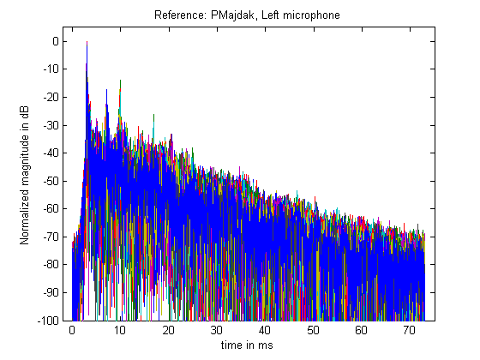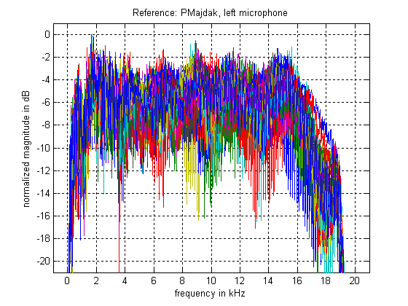Figure 1: Raw reference data from the reference measurement for the left microphone and 22 audio channels. Left panel: normalized IRs (in dB). Right panel: normalized amplitude spectra (in dB). The different colors show the 22 different audio channels.
One possible solution could be to measure the reference data for every spatial position. However, since the position of the microphones varies for each subject and each HRTF position, it would be necessary to adapt the reference measurements to the particular subject and repeat them for all positions. This approach would result in much more data and much more complex post-processing, making the measurement of the HRTFs much more difficult.
Thus, another way of removing the room effect is proposed, basing on the following assumptions:
- The delay between the direct sound and the most prominent reflections is assumed to be very long. This yields in a comb filter effect, where the amplitude spectrum has very fast fluctuations.
- Multiple reflections are assumed, causing the amplitude spectrum fluctuations to be very stochastic.
- The amplitude spectrum of the equipment is assumed to be very smooth, considering a high-quality loudspeakers, microphones, and the corresponding amplifiers.
With these assumptions, the equipment amplitude spectrum are supposed to be smoother than the room amplitude spectrum, showing a structural difference between the room effect and the equipment effect, and providing a basis for separation the two effects. Transforming the raw reference data to cepstrum (Bogart et al., 1963), the smooth spectral components of the equipment appear around the quefrency of zero. The stronger fluctuating spectral components of the room caused by reflections appear as smeared peaks. We define the cut-off quefrency, , which separates the equipment effect from the room effect in cepstrum. With , the spectrum of the raw reference data can be smoothed reducing the room effect but not strongly affecting the equipment transfer functions.
In order to determine , the transfer function of each equipment audio channel was measured without the room effect. This was realized by placing the loudspeaker and the microphone in the room in such a way that the room reflections occur after the main fade-out of the direct signal. Then, for each audio channel, the system identification procedure was applied and the cepstrum was calculated. The results for two typical channels are shown in Fig. 2. The first peak in the cepstrum, representing the first room reflection, was found to be at the quefrency of 5.25 ms for all channels. The most cepstra decayed within 4 ms. The stagnation of the decay, indicating no further contribution of the equipment, begins between 3 and 4 ms, depending on the channel. For further calculations, we will use . Note that the estimation of is required only at the very first build-up of the equipment and is not required at the HRTF measurements. The estimation of should, however, be validated, when equipment components like loudspeakers change.
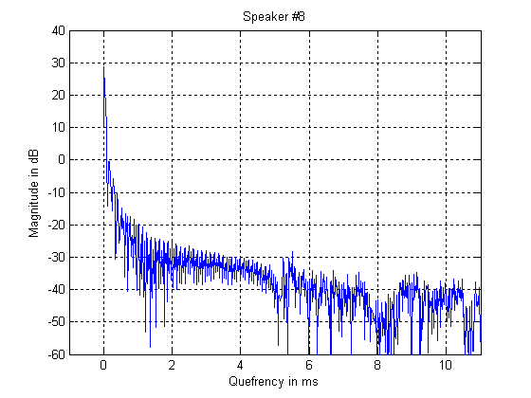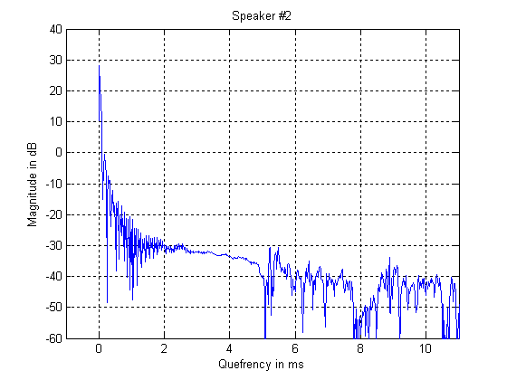Figure 2: Cepstrum (in dB) for two typical audio channels without the reduced room effect (see text).
=3.8 ms
Before the HRTF measurement, the reference measurement is performed. With , the raw reference data are cepstrally smoothed using a low-pass lifter configured to . This results in IRs, which decay quickly (within 7 ms down to -60 dB, see Fig. 3, left panel) compared to the raw reference data (decay within 50 ms, see Fig. 1, left panel). Also, the amplitude spectra are more smooth now (see Fig. 3, right panel). A Tukey window is applied to crop the region from 1.5 to 7 ms of the IRs. The Tukey window is configured to a fade in of 0.5 ms and fade out of 1.5 ms. The resulting IRs have the length of 5.5 ms.
In each IR, the room effect has been drastically reduced. However, each IR represents a mixed-phase system, consisting of both the minimal and maximal phase components. For a further equalization, only minimal phase filters are of interest because equalizing a signal with filters which contain maximal phase components yields in unstable or uncausal results (Oppenheim and Schafer, 1998, pp. 288). Thus, in each IR, the phase spectrum is replaced by the minimal phase spectrum. The minimal phase spectrum is calculated using the Hilbert transform (Oppenheim and Schafer, 1998, pp. 788).
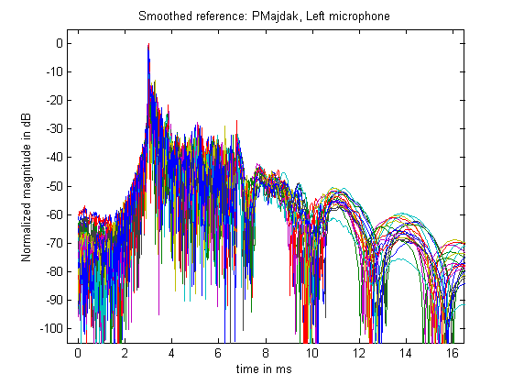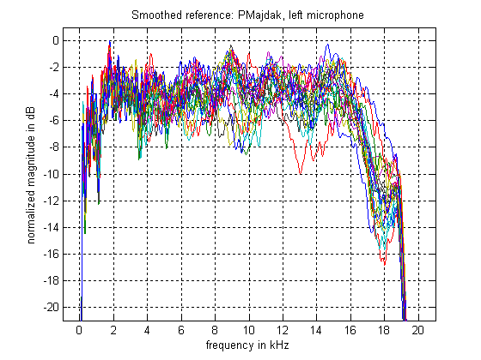Figure 3: Cepstrally-smoothed reference data (low-pass lifter with a cut-off quefrency of 3.8 ms). Left panel: normalized IRs (in dB). Right panel: normalized amplitude spectra (in dB). The different colors represent different audio channels.
These post-processed reference data, are shown in Fig. 4. They show reduced room effect, contain the minimum-phase information about the equipment, and have the length of 5.333 ms. We assume that they represent the equipment effect:
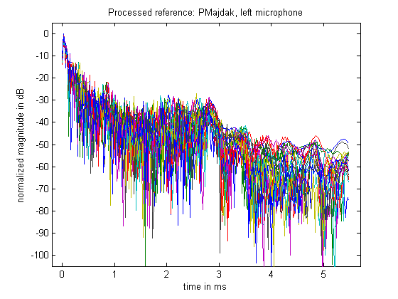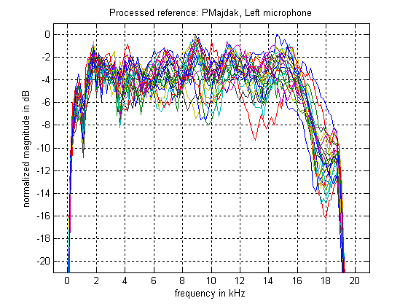Figure 4: Post-processed reference data. Left panel: normalized IRs (in dB). Right panel: amplitude spectra (in dB). The different colors show different loudspeakers.
(2.2)
and thus treat these data as equalization filters for further processing.

Head Related Transfer Functions (HRTF)
The raw HRTFs can be represented in a similar way as the raw reference data:
, | (3.1)
where corresponds to the recorded raw HRTFs, is the transfer function of the equipment, is the transfer function of the room (chamber), and is the actually desired HRTF. Figure 5 shows examples for raw HRTFs for the positions front (0°), left (90°), back (180°), and right (270°) in the horizontal plane.
In order to remove both the room and the equipment effects, Eq. 3.1 is reformulated:
(3.2)
where represents the equipment-equalized HRTF.
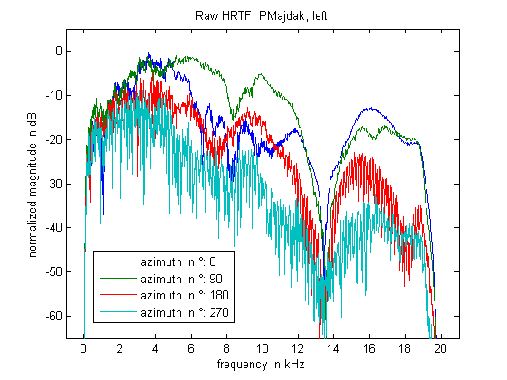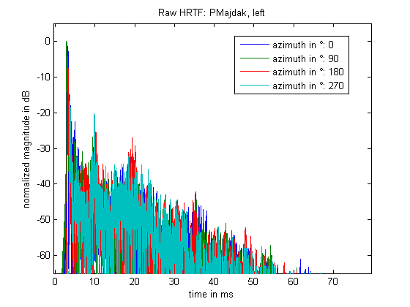Figure 5: Raw HRTFs for the left ear. Left panel: normalized IRs. Right panel: normalized amplitude spectra. Different colors represent the HRTFs for position 0°, 90°, 180°, and 270° in the horizontal plane.
In a first step, the equipment effect is reduced. We call this process equalization and is calculated from with the equalization filters from the reference measurement:
. | (3.3)
Note that the post-processed reference data, are assumed to represent the equalization filters ().
The equalization is performed by dividing the complex spectrum of the raw HRIRs by the complex spectrum of equalization filters separately for each audio channel (Fielder, 2003). In order to increase the frequency resolution, the raw HRIRs are zero-padded to 100 ms before Fourier transformation. The complex division is applied only within the frequency range where the equalization filters have much energy, which is from 300 Hz to 18 kHz (see Fig. 4). This avoids a regularization proposed by Fielder (2003). The amplitudes for frequencies below 300 Hz and above 18 kHz are set to zero. After division and inverse Fourier transformation, windowing to a length of 9 ms is applied. Figure 6 shows the resulting equalized HRTFs, .
In the next step, in order to obtain , the room effect, is reduced in . This is done by applying the cepstral smoothing procedure from the reference measurement to : First, is zero-padded to the length of 50 ms; then, it is cepstrally smoothed using a low-pass lifter configured to the cut-off quefrency =3.8 ms. This yields in 50-ms long HRIRs, .
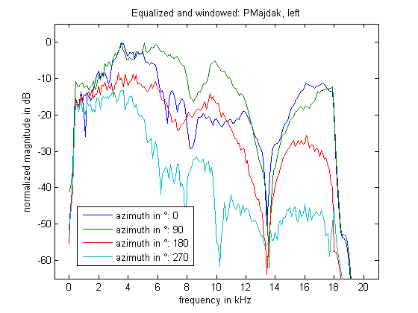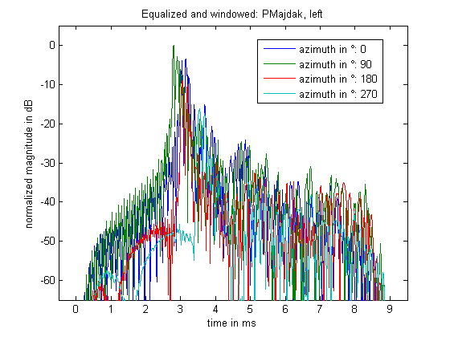Figure 6: Equalized HRTFs for the left microphone. Left panel: normalized IRs. Right panel: normalized amplitude spectra. Different colors represent the HRTFs for position 0°, 90°, 180°, and 270° in the horizontal plane.
These HRIRs are further windowed to the length of 5.333 ms, which corresponds to 256 samples at the sampling frequency of 48 kHz. Figure 7 shows an example of four short HRTFs.
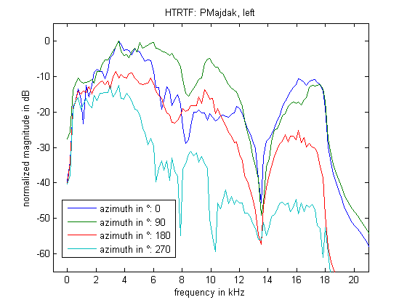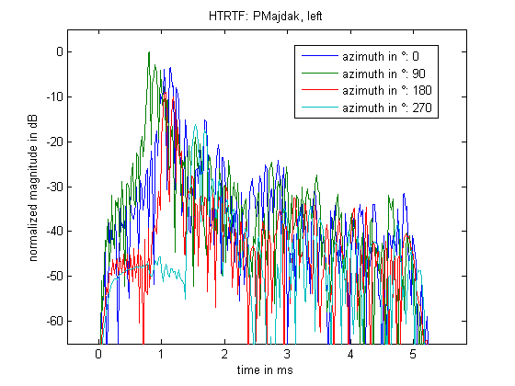Figure 7: Post-processed HRTFs for the left ear. Left panel: normalized IRs. Right panel: normalized amplitude spectra. Different colors represent the HRTFs for position 0°, 90°, 180°, and 270° in the horizontal plane.
Now, in the post-processed HRTFs, the room and equipment effects are substantially reduced and the filters contain mostly the effects of the head, pinna, and torso. The HRIRs have the length of 5.333 ms and frequency range from 300 Hz to 18 kHz. Examples of the post-processed HRTFs for the horizontal and median plane is shown in the Figure 8.
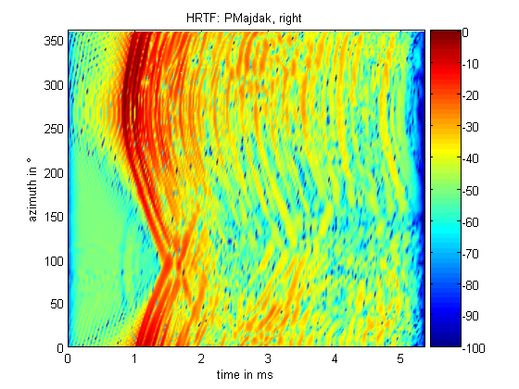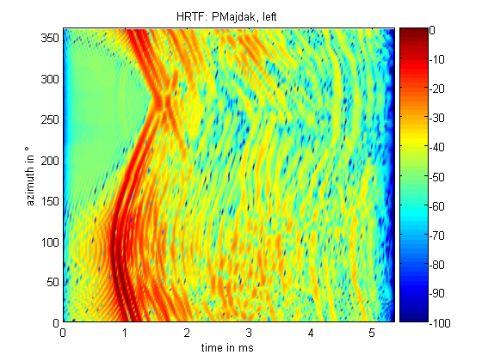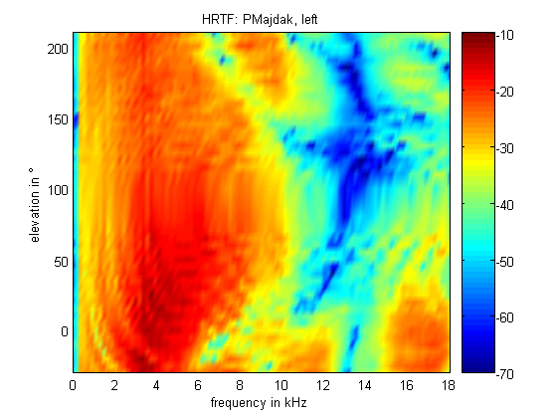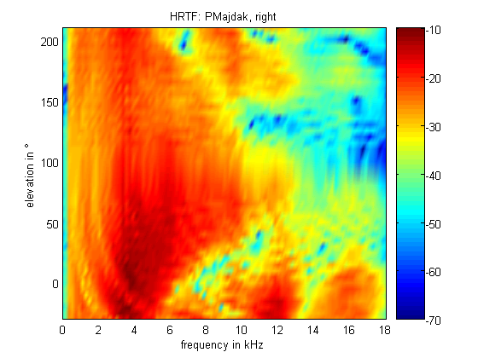
Figure 8: Post-processed HRTFs. Upper panels: normalized IRs in the horizontal plane. Lower panels: normalized amplitude spectra in the median plane. The colors correspond to the magnitude in dB. Left and right panels correspond to the left and right ear, respectively.

Directional Transfer Functions (DTF)
Each HRTF can be considered as a result of the convolution of two transfer functions, the directional transfer function (DTF) and the common transfer function (CTF, Middlebrooks and Green, 1990). The CTF contains the direction-independent portion of the HRTF such as effects of the ear canal. Removing the CTF from the HRTFs reduces the detailed acoustic effects associated with the precise location of the in-ear-microphones and emphasizes the directional effects in the HRTFs.
In order to calculate the CTF, its amplitude spectrum is approximated by averaging the real cepstra of HRTFs for all available positions for one ear. The phase spectrum of the CTF is considered to be a minimal phase. We use the equalized, not the final HRTFs to calculate the CTF. Each HRTF is transformed to a real cepstrum. All cepstra are averaged and the average cepstrum is transformed to the frequency domain. The minimal phase for the amplitude spectrum is calculated using the Hilbert transform. The amplitude and phase spectra are combined to build the raw CTF. The raw CTF still contains the position-dependent components of the room effect. Thus, the raw CTF is cepstrally smoothed using the procedure from the reference measurement. Finally, the smoothed CTF is windowed to a length of 5.333 ms. Figure 9 shows the CTFs for both ears. Note the low-pass-filter characteristic which is assumed to be an effect of the head, which absorbs more energy in the higher frequency region than in the lower frequency region.
The calculation of DTFs is performed by removing the CTF from each HRTF for one ear. This is achieved by dividing the equalized, not the final HRTF by the corresponding CTF within the frequency range of 300 Hz to 18 kHz. The amplitudes outside of that range are set to zero. The result is the raw DTF, which is then cepstrally smoothed using the procedure from the reference measurement and yields the final DTFs. As for the HRTFs, the DTFs are additionally windowed to a length of 5.333 ms to obtain filters for convenient filtering of free field sounds.
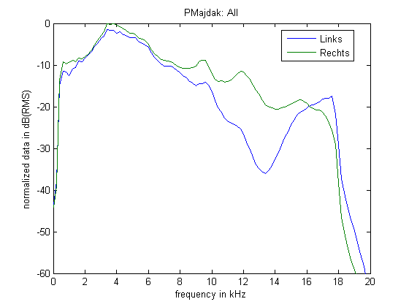Figure 9: Amplitude spectra of the common transfer functions for the left and right ear
Because of the low-pass-filter characteristic of the CTF, the calculation of DTFs corresponds to a whitening process: Compared to the HRTFs, the amplitudes in the high frequency region are elevated, see Figures 10 and 11.
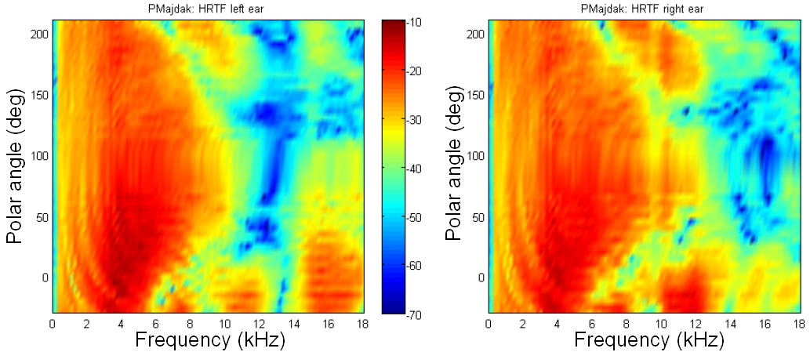Figure 10: Comparison of the HRTFs left and right. Both panels show the amplitude spectra in the median plane.

References
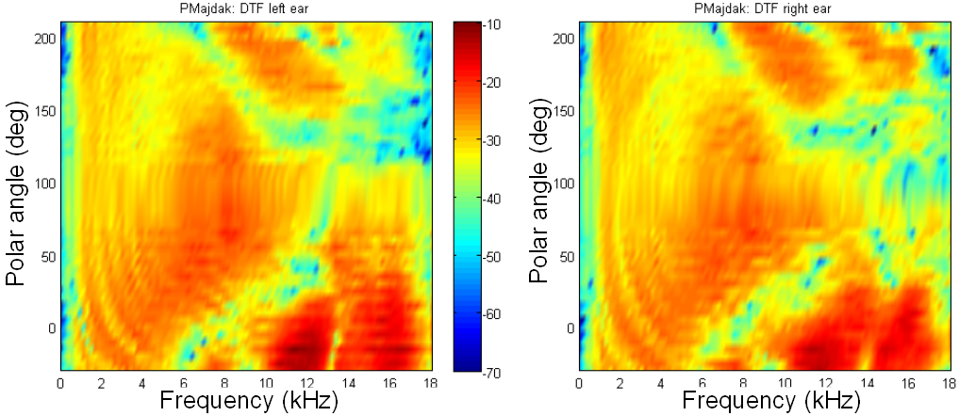Figure 11: Comparison of DTFs left and right. Both panels show the amplitude spectra in the median plane.
Bogert, B. P., Healy, M. J. R., and Tukey, J. W. (1963). "The quefrency alanysis of time series for echoes: cepstrum, pseudo-autocovariance, cross-cepstrum, and saphe cracking," in Proceedings of the Symposium on Time Series Analysis edited by M. Rosenblatt (Wiley, New York).
Fielder L. D. (2003). “Analysis of Traditional and Reverberation-Reducing Methods of Room Equalization,” J. Audio Eng. Soc. 51, 3-26.
Majdak, P., Balazs, P., and Laback, B. (2007). "Multiple exponential sweep method for fast measurement of head-related transfer functions," J Audio Eng Soc 55, 623-637.
Middlebrooks, J. C., and Green, D. M. (1990). ‘‘Directional dependence of interaural envelope delays,’’ J. Acoust. Soc. Am. 87, 2149–2162.
Oppenheim, A. V. and Schafer, R. W. (1998). Discrete Time-Signal Processing, 2nd ed. (Prentice Hall, New Jersey).

In our setup, each audio channel represents one vertical position.
The raw reference data are saved in “hrtf_M_ref1.mat”. Use “hrtf_CalcREF” to perform all calculations in this chapter at once.
Use “AA_SmoothCepstral” to perform cepstral smoothing.
Use “AA_Window” to perform windowing and fading.
Use “AA_MinimalPhase” to replace the phase by the minimal phase.
The post-processed reference data are saved in “hrtf_M_ref1 processed.mat”.
The post-processed reference data are saved as equalization filters in “hrtf_FILT_ref1 processed.mat”. Generally use “AA_CalcSaveFILT” to save IRs as filters.
The raw HRTFs are saved in “hrtf_M_raw.mat”. Use “hrtf_CalcREF” to perform all calculations in this chapter at once.
Use “AA_Equalize” to perform an equalization.
The equalized HRTFs are saved in “hrtf_M_equ.mat”.
The long final HRTFs are saved in “hrtf_M_hrtf.mat”.
The short final HRTFs are saved in “hrtf_M_hrtf 256.mat”.
Load “hrtf_M_hrtf 256.mat” and start “hrtf_ShowData” to get some nice plots of the HRTFs.
Use “AA_AverageCepstral” to calculate cepstral averages.
The calculations in this chapter are a part of “hrtf_CalcALL” from the previous chapter.
The CTFs are saved in “hrtf_M_ctf.mat”.
The long DTFs are saved in “hrtf_M_dtf.mat”.
The short DTFs are saved in “hrtf_M_dtf 256.mat”.
Load “hrtf_M_dtf 256.mat” and start “hrtf_ShowData” to get some nice plots of the DTFs.

